Assignment One

**Business Case Proposal**

**“Off-the-Grid” at Lakeside Drive Community Garden**

by

Alan Hubbard

S326012

for

Dr Hooman Mehdizadeh-Rad

PMO201 Project Management

Word Count: 1878

# Table of Contents

* 1. Executive Summary
  2. Reason for Doing the Project
  3. Objectives
  4. Quantitative Analysis
  5. Business Options
  6. Project Requirements
  7. Cost
  8. Major Risks
  9. Timescale
  10. Major Milestones
  11. Conclusion and References

# Executive Summary

The Lakeside Drive Community Garden is a non-profit organisation that provides a native and edible garden for like minded people to learn sustainable gardening practices, understand permaculture principles, allow people to grow their own fruits, vegetables, herbs and flowers, and foster community engagement. (Lakeside Drive Community Garden. 2020, Permaculture Darwin. (n.d.)

The community garden has very limited income due to low memberships and no product output and distribution. This results in the requirement for government and community grants to provide funds for development of the community garden and general upkeep and maintenance costs, such as repair of infrastructure and water supply costs.

Within the last 12 months, government and community grants have allowed the building and installation of a fence, shed and new irrigation system. This has provided security to the community garden, added shelter for meetings and community events and a storage location for gardening supplies and improved water flow and access to the full width of the garden area.

The shed provides a new and unique space to meet and hold events at the community garden, however without the provision of power, limits the types of events and times they can be conducted.

With the new irrigation system installation, the gauge of inlet was increased from 25mm to 50mm. Whilst this allows for greater water flow, it is also expected that the water usage will increase with this access. As such, it is important to reduce costs where possible.

The Patch is another organisation within the community garden area that provides individuals and groups with special needs and difficulties with traditional schooling assistance and learning in non-traditional methods. The Patch has a separate line of funding from the Department of Education, Employment and Training, NT, for the purposes of their programs.

1. Reasons for Doing the Project

This proposal provides opportunity for the LDCG to become more self-sufficient regarding power and water supply and consumption. Currently there is no power, 240V or otherwise, within the grounds, relying on volunteers to charge batteries at their own residence and bring portable power tools to the location. The lack of power also removes options for providing lighting for safety and security purposes.

By providing power, from renewable energy sources, this allows for greater flexibility within the Community Garden to conduct maintenance and other activities, whilst demonstrating the benefits and applications of renewable energies. Other potential benefits that will be afforded by the establishment of a green power supply is establishment of relationships with local industry with the Darwin community, promotion of renewable resource proliferation and greater visibility by the public. (Permaculture Darwin. n.d.)

1. Objectives
   1. Install power supply that relies on renewable energy source that does not require external sources/support.
   2. Provide power storage and conversion to usable power.

**SWOT Analysis**

Strengths

* Reduces operating costs and reliance on other organisations
* Advocates sustainable gardening/farming practices
* Reinforces principles of permaculture and LDCG
* Adds power supply and storage to LDCG not currently available.

Weakness

* High cost and no/little financial payback
* Reliance on funding grants and donations as self-funding is unavailable or limited
* Parties involved in LDCG are almost all volunteers therefore limited assistance is available
* Maintenance cost forecasting needs to be considered for maintenance and damage due to the harsh Darwin weather and environment

Opportunities

* NT and Federal Grants for sustainable energy projects
* Specialist assistance and advice from CDU faculty and students
* Project may be modified/reduced to decrease financial burden
* Increased publicity may invite donations, either financial or through equipment, advice or labour
* Support through advertising may be used in lieu of payment

Threats

* May require approval from CDU, as the land is owned by CDU
* Permanency of location is in doubt; any investment may require relocation
* Cyclone coding and certification incurs additional cost
* Funding source for future maintenance and repairs may need to be included in this Project Proposal

# Quantitative Analysis

# Weighted Scoring Model

|  |  |  |  |  |  |  |  |
| --- | --- | --- | --- | --- | --- | --- | --- |
| **Project Title** | | Solar Power | | Water Collection and Storage | | Marketing Program | |
|  | Weight | Rating | Weighted Value | Rating | Weighted Value | Rating | Weighted Value |
| Cost | 40% | 1 | 0.4 | 3 | 1.2 | 5 | 2 |
| Benefit | 5% | 6 | 0.3 | 1 | 0.05 | 3 | 0.15 |
| Specialist/Ongoing Support | 10% | 3 | 0.3 | 5 | 0.5 | 7 | 0.7 |
| Advertising Potential | 20% | 10 | 2 | 5 | 1 | 10 | 2 |
| Supports LDCG Principles | 25% | 10 | 2.5 | 8 | 2 | 0 | 0 |
| Total |  |  | 5.5 |  | 4.75 |  | 4.85 |

The Weighted Scoring Model was used to determine the most beneficial project due to the lack of return on investment. The projects proposed are: Solar Power and Storage, Water Collection and Storage and the Marketing Program.

Rating determination. Ratings were determined on a scale of 0 to 10, 0 being the lowest score and 10 being the highest. In the case of Cost and Specialist/Ongoing Support a low score indicates a higher cost and greater requirement.

# The Solar power project will provide power within the site without the ongoing cost of connection to the city power grid. This allows for further development of the community garden that requires the provision of 240v power supply, such as the use of power tools and the installation of security systems.

## Business Options are divided into two factors and are as follows:

**Power generation** (the form that power is generated)

Solar – photovoltaic (PV) cell solar panels placed on existing or new structures to convert sunlight to electricity

Wind – turbines that convert wind to electricity.

Combination – A combination of wind and solar to maximise power generation and to mitigate power generation loss when one is lacking, e.g. at night no solar power is generated.

**Power Storage** (conversion to 240v to be included)

Nil, connection to power grid – No power storage on site. The site is powered by the city power grid and excess power generated is diverted into the grid.

Tesla Power Wall – 13.5kWh usable capacity

Lithium Batteries – scalable capacity with high Depth-of-Discharge

AGM Deep Cycle – scalable capacity, low cost, low Depth-of-Discharge

(Natural Resources Defense Council. (2018), Off-Grid Energy Australia. (n.d.), Solar Batteries Online. (n.d.) Tesla. (n.d.).)

# Project Requirements

## Requirements for this Project.

Approval by Darwin City Council and Charles Darwin University. All building modifications such as this require approval by Darwin City Council, further the property is owned by Charles Darwin University, therefore will also require approval by them.

Funding by NT Government or other organisations.

Require installation of all equipment and infrastructure to support the project.

## Constraints of this project.

Approvals. Approvals required for this project will reside with the Lakeside Drive Community Garden Committee, Charles Darwin University and City of Darwin.

Funding. Funding required for this project is estimated to be up to $50 000. The Community Garden does not currently have sufficient funds to allocate to a single project and as such fund must be sought from outside the organisation the government and non-government organisations.

Volunteer groups. The Lakeside Drive Community Garden is an organisation that requires the commitment and investment of volunteers to ensure its continued success. Therefore, consultation is the volunteer groups must be considered through consultation.

Other interest groups. Other interest groups that participate or have an investment in the community garden must also be considered. There are a number of financial supporters of the community garden that are stakeholders and may have conditions for their support. There are also groups, such as the Little Gardeners, that use the community garden regularly for small group events. These groups’ aims also need to be considered to ensure their continued attendance at the community garden.

# Costs

# Overall Project cost estimate is $50 000

# Power Storage Options

# Tesla power wall (approximately 1000Ah) $10 000

Lithium Battery power bank $1000/100Ah

AGM Battery power bank $500/100Ah

**Power Generation Options**

Solar panel array 6kW $15 000

Wind turbines $8 000 - 20 000

**Other**

Installation $10 000

Certification $5 000

Inverter $2 500

Grid Connection $5 000

# Major Risks

# Risk Identification and Appreciation.

Approval is not given or withdrawn

Existing structures are not suitable for solar panel installation

Actual costs exceed project budget

Power storage solution does not hold enough power or is unusable

Damage to infrastructure or equipment

|  |  |  |  |
| --- | --- | --- | --- |
| **Risk** | **Likelihood** | **Consequence** | **Result** |
| 1. Approval | 1 Rare | 3 Moderate | 3 Low |
| 2. Structure Suitability | 3 Possible | 4 Major | 12 High |
| 3. Unforeseen Cost | 3 Possible | 4 Major | 12 High |
| 4. Power output | 2 Unlikely | 2 Minor | 4 Moderate |
| 5. Damage | 4 Likely | 4 Major | 16 Extreme |

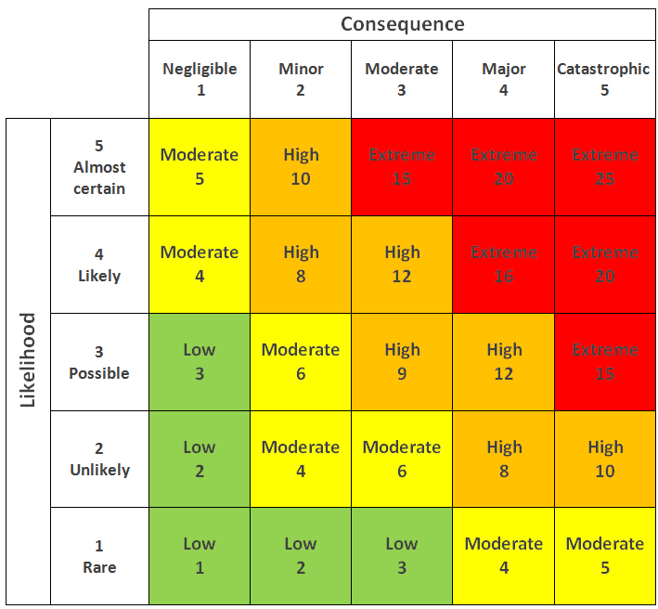

Figure 1.1. Standard Risk Matrix (Research Gate. 2020)

# Risk management

Risks will be managed in the following methods for the above identified risks.

Approval is not given or withdrawn.

Detailed consultation with interested parties is to be conducted and recorded to ensure all parties understand the project scope and proposal. Clear approval is to be sought and received prior to project initiation.

Existing structures are not suitable for solar panel installation.

Inspections are to be conducted prior to the commitment of using existing structures for installation of solar panel. Should the existing structures be identified as unsuitable, an alternate solution is to be pursued. i.e. building of a specific solar panel structure.

Actual costs exceed project budget. Due to the lack of funding availability within the community garden, is it critical that the budget remain within or below the allowable tolerances. This will be achieved by detailed and accurate estimates of costs in consultation with key specialists. Further the budget is to include a buffer that will be used as a reserve in the event of unexpected costs.

Power storage solution does not hold enough power or is unusable. The power solution must be delivered in a useable and sufficient storage quantity for use during periods of inconsistent supply. This will be mitigated through detailed investigations on the requirements and consultation with industry specialists.

Damage to infrastructure or equipment. Due to the harsh weather events that occur in Darwin, damage to the infrastructure presents a distinct risk to the extent of the life of the project. The project is to include funding that covers insurance for up to 10 years.

# Timescale

# Estimated Timeline. This project is expected to take not more than 12 months.

# Major milestones.

* Month 2. Equipment and infrastructure specification needs identified and confirmed
* Month 4. Application for Government and Non-Government grants or donations.
* Month 5. Funds approved/received and accounted for. Followed by assessment of allocation of funds to the project requirements.
* Month 6. Identification of contracted suppliers.
* Month 7. Contracts with installers confirmed.
* Month 7-10. Build Start.
* Month 11. Build Complete.
* Month 12. Certifications and funds acquittal finalised.

1. Project Milestones

# Design of Energy production and storage source.

# Grant funding approval and donation receipt or commitment.

# Installation of energy production and storage infrastructure

# Certification approval

# Funds acquittal

# Conclusion and References

This project is aimed to improve and develop the Lakeside Drive Community Garden by providing constant power to the premises. This will allow for a greater breadth of activities, such as power to tools and lighting, as well as providing provisions for future applications such as power for security systems.

The project requires significant financial assistance from government and non-government organisations, through grants and donations (either financial or through materiel support). As such, the funding and accurate budgeting and monitoring of the budget is critical for the project.

References

Lakeside Drive Community Garden. (2020). *About Us.* <https://ldcg.cdu.edu.au/>

Permaculture Darwin. (n.d.) *Our Gardens.* <https://sites.google.com/site/permmacultureindarwin/our-gardens/lakeside-drive-community-garden>

Research Gate. (2020). *A Standard Risk Martix.* <https://www.researchgate.net/figure/A-standard-risk-matrix_fig7_323570642>

Off-Grid Energy Australia. (n.d.). *Wind Turbines.* <https://www.offgridenergy.com.au/off-grid-power-systems/components/wind-turbines/>

Solar Batteries Online. (n.d.) *Lithium Ion, LFP Batteries.* <https://solarbatteriesonline.com.au/lithium-ion-lfp-lithium-batteries/>

Natural Resources Defense Council. (2018). *Renewable Energy: The Clean Facts* <https://www.nrdc.org/stories/renewable-energy-clean-facts>

Tesla. (n.d.). *Powerwall.* <https://www.tesla.com/en_AU/powerwall>